# BIOS 6642 Final Project

Samantha Bothwell

**Username/Password**

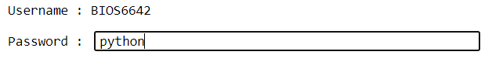

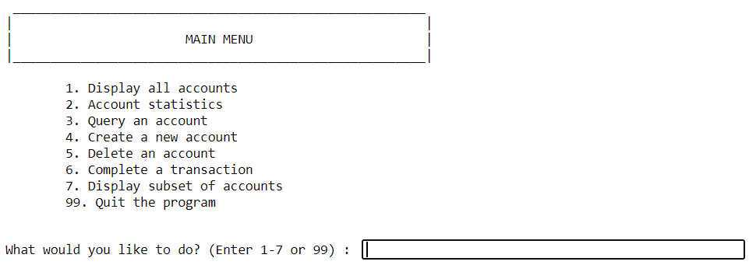**Main Menu**

1. **Display All Accounts**

**Sorted by Account number (Default)**

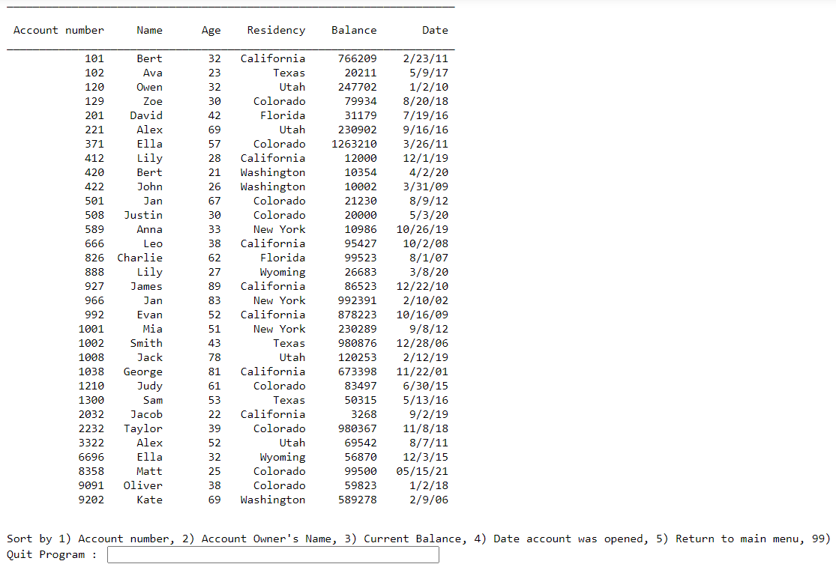

**Sorted by Name**

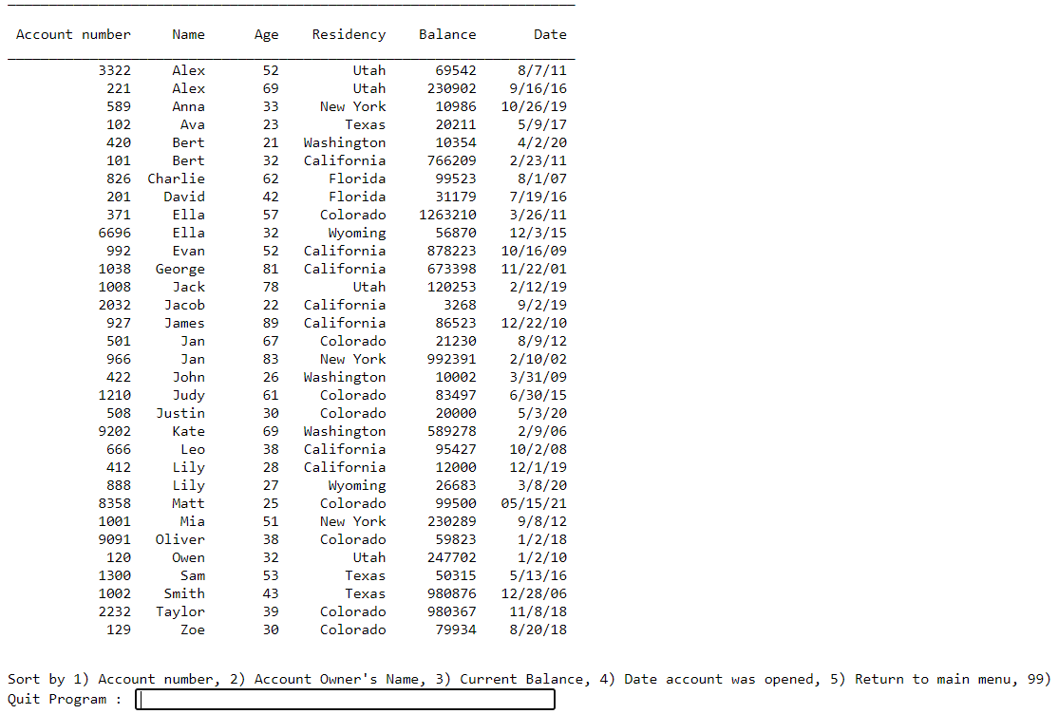

**Sorted by Balance**

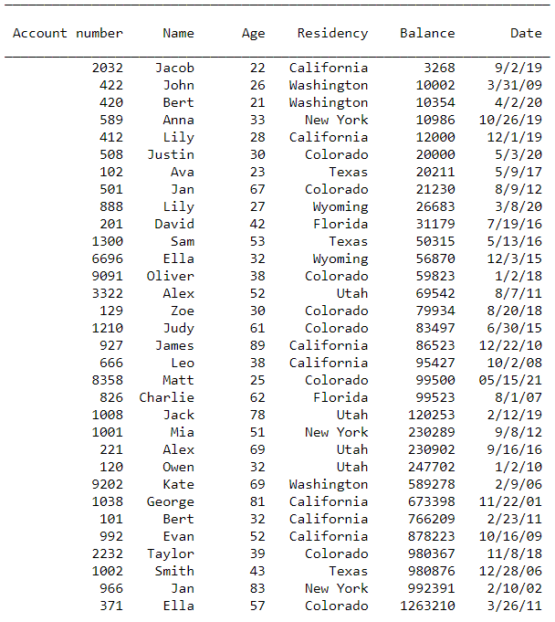

**Sorted by Date Account was opened**

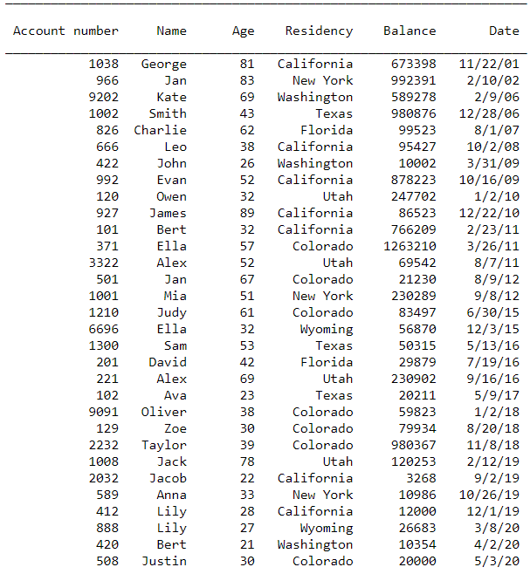

1. **Account Statistics**

**Overall**

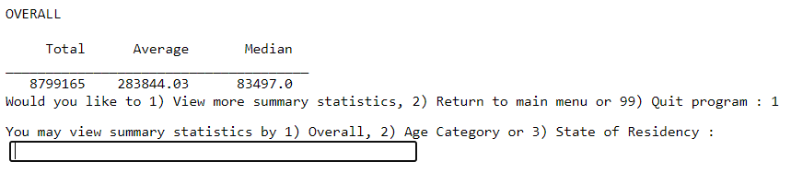

**By Age Category**

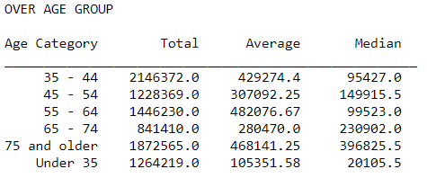

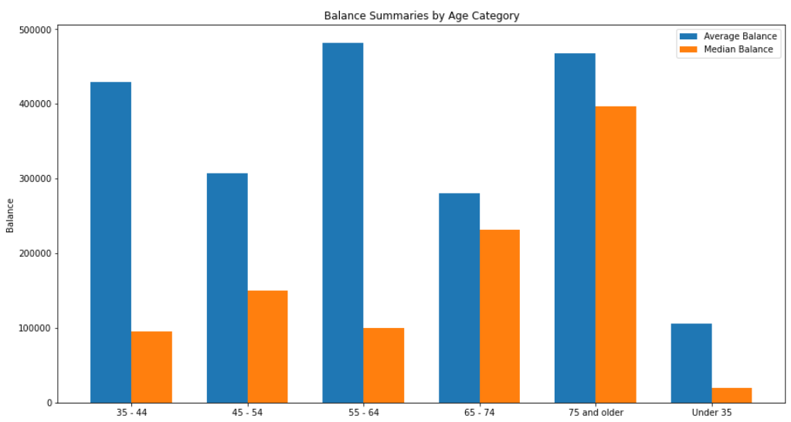

**By State**

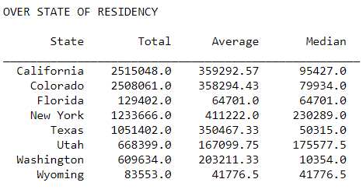

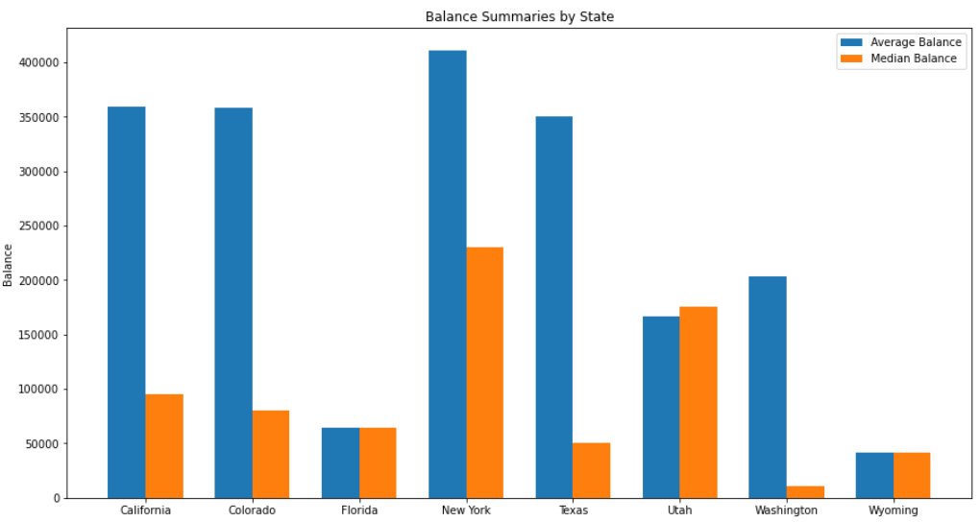

1. **Query an Account**

**By Account Number**

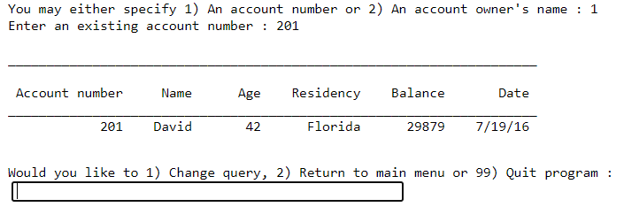

**By Account Owner**

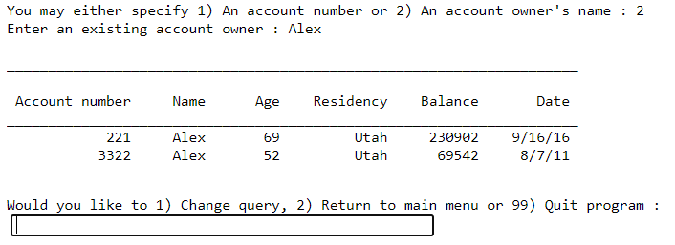

1. **Create a New Account**

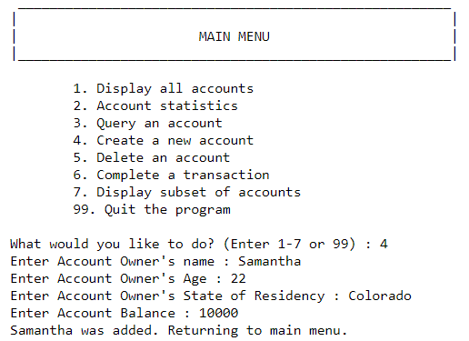

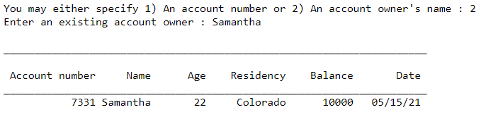

1. **Delete an Account**

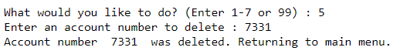

The following output is sorted by account number and shows that 7331 was deleted.

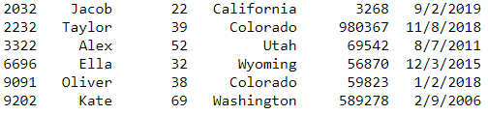

1. **Transactions**

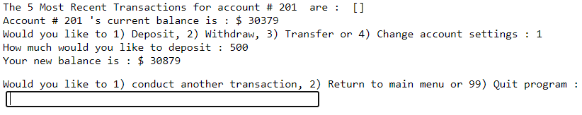**Deposit**

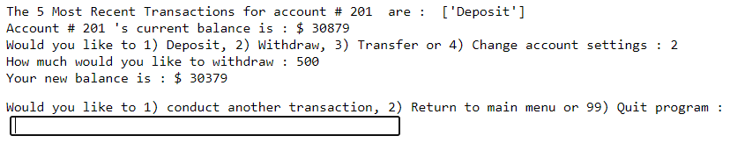**Withdraw**

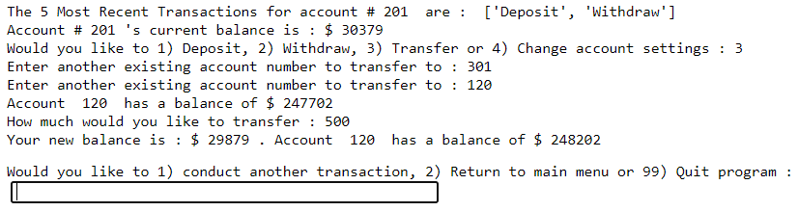**Transfer**

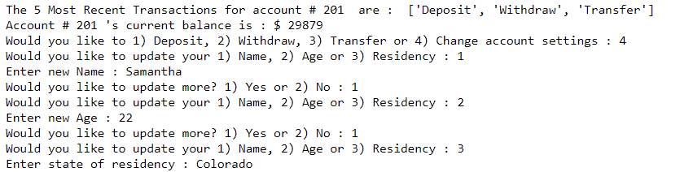**Change Name, Age and Residency**

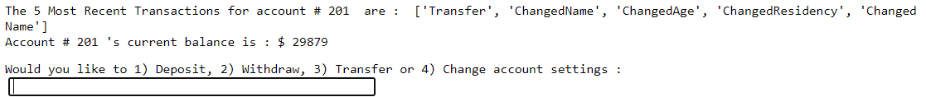

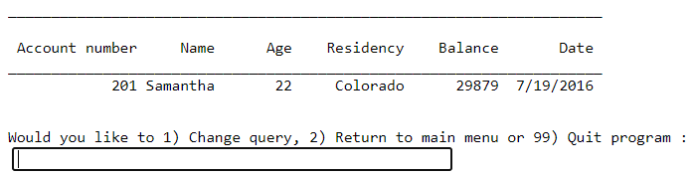

1. **Display Subset of Accounts**

**Subset by Age**

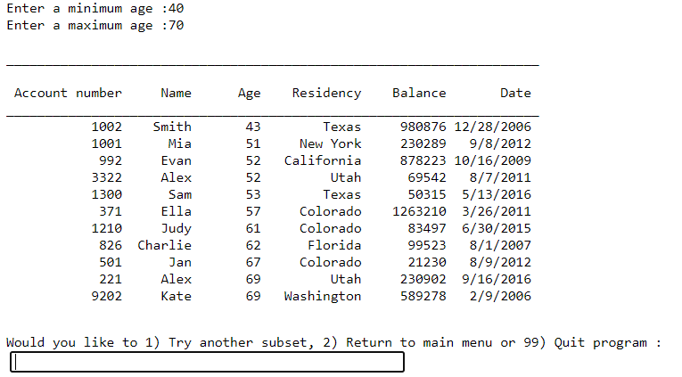

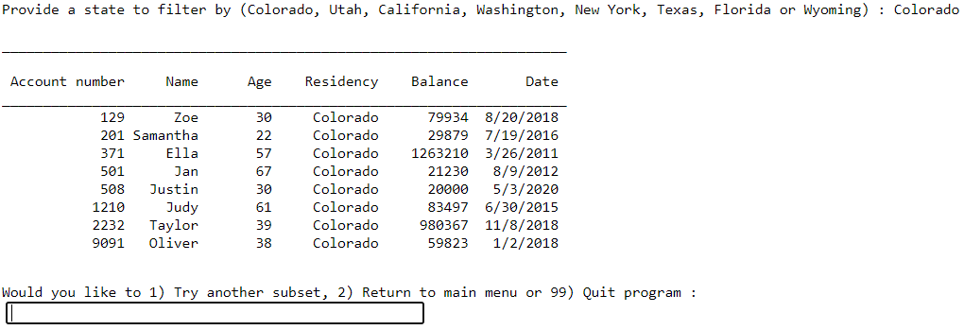**Subset by State**

**Subset by Date Accounts were opened**

